Power BI Assignment 3 – Fleet Performance & Delivery Efficiency
Project steps and objective:
- Data Cleaning & Modelling: (5marks)

○ Fix missing fuel consumption values (use avg. per vehicle type).
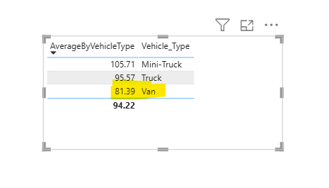

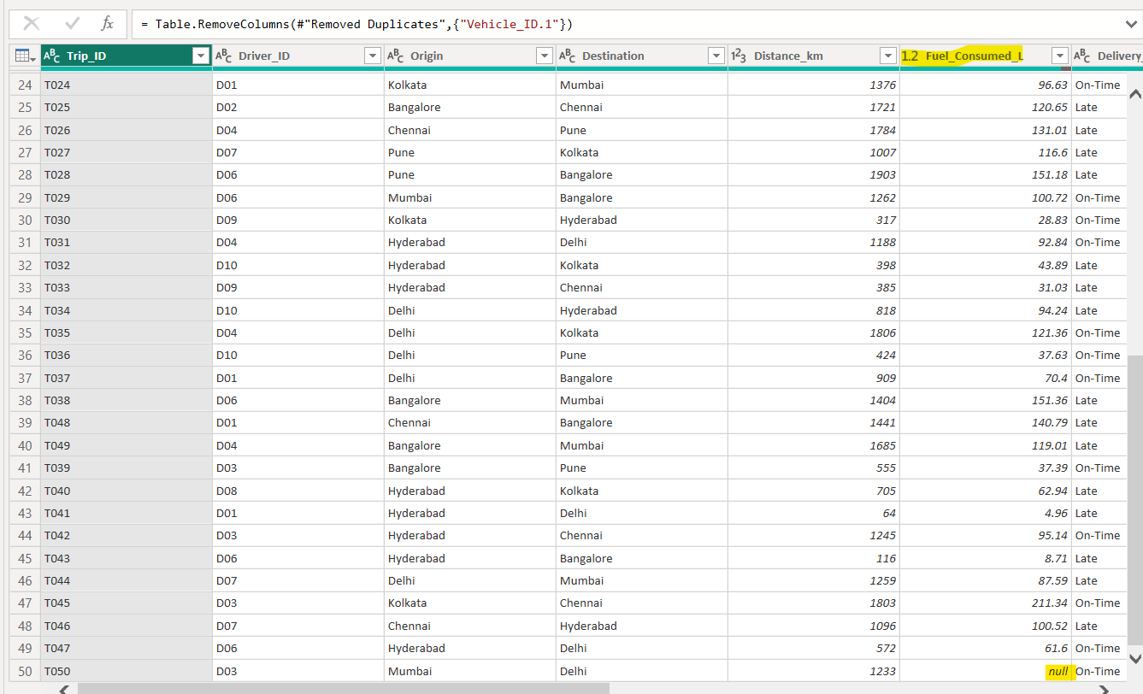

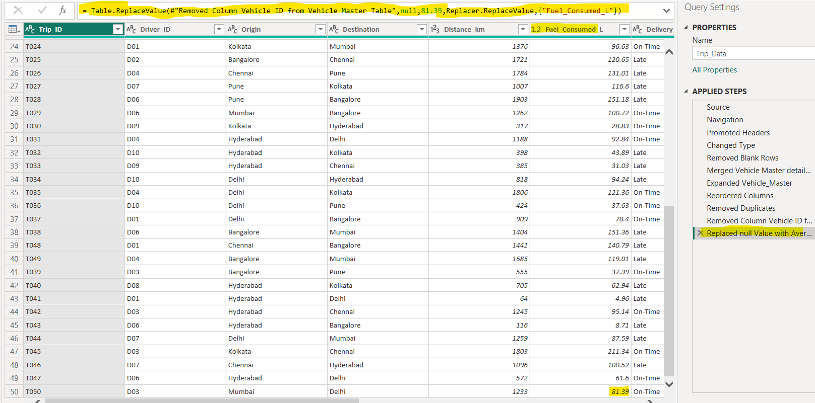

○ Relate Trips with Vehicle Master.
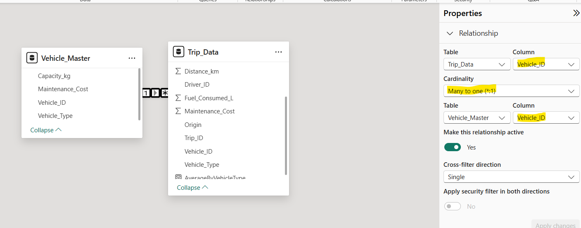

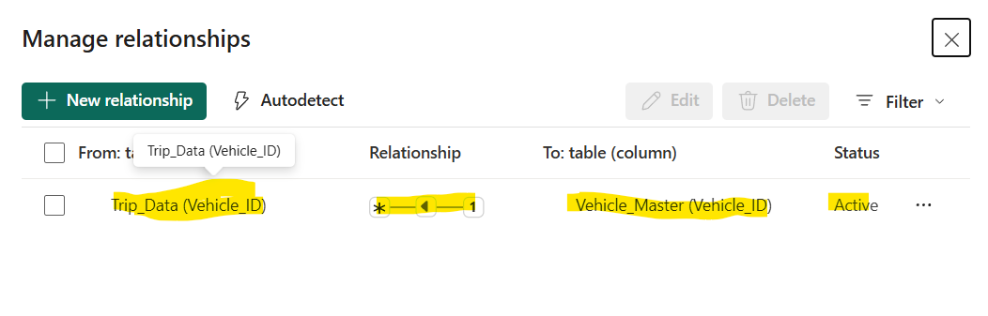

- DAX Measures: (5marks)

○ Fuel Efficiency = Distance / Fuel Consumed

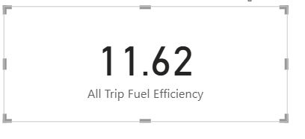
○ On-Time Delivery % = On-Time Trips / Total Trips
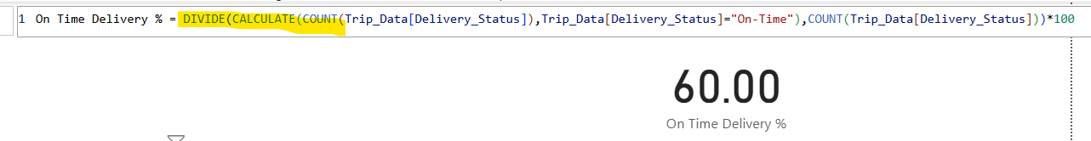

○ Cost per km = (Fuel Cost + Maintenance Cost) / Distance
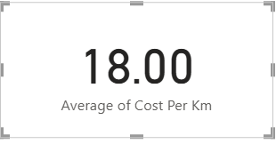

- Visualization: (5marks)
○ Bar chart: On-Time Delivery % by Route.

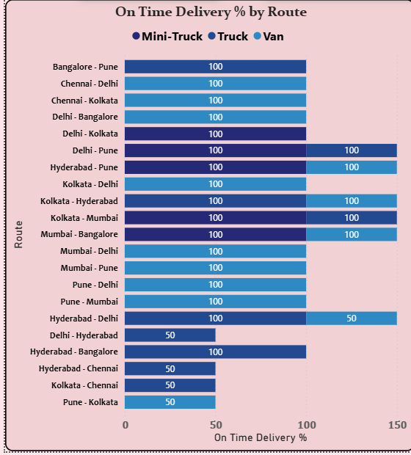
○ Line chart: Fuel Efficiency trend by month.
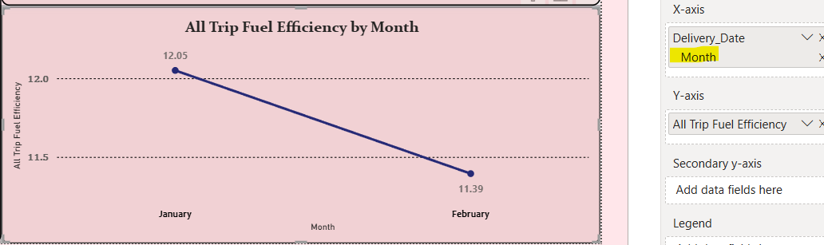

○ KPI cards: Avg. Delivery Time, Cost per km.
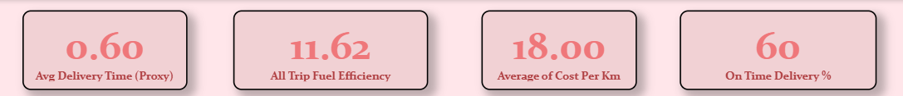

○ Map visual: Delivery performance by route (Origin → Destination).
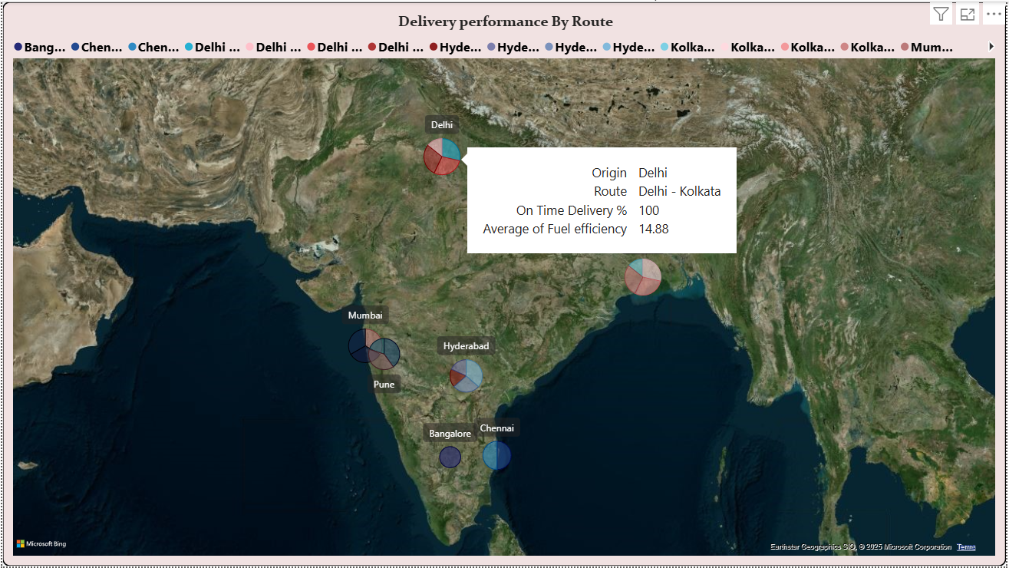

Using a route Map:
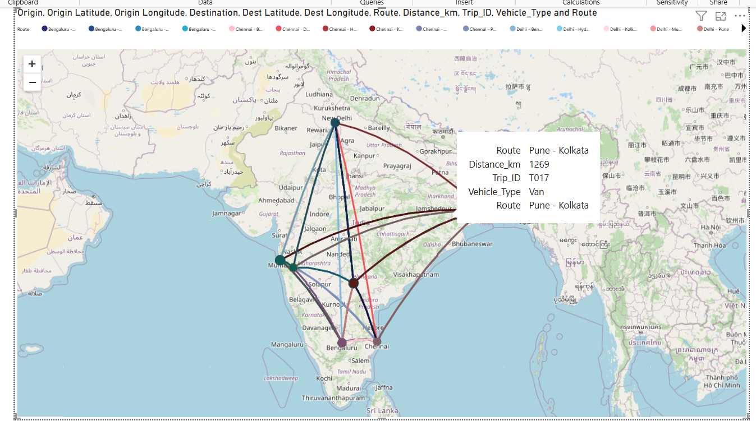

Expected Output: A transport operations dashboard to optimize routes and fleet usage.
